Play with Bootstrap - 3
Send Feedback

This is your third assignment. The image that you see in the background is not repeated but actually, have a parallax effect.

You have these new features to build on this page -
There is a fixed navigation bar at the top of the page.
Then, we have used carousel with two images.
Look for 'Jumbotron' and 'Cards Layout' to build the below section.

On a large screen and above, it looks like -
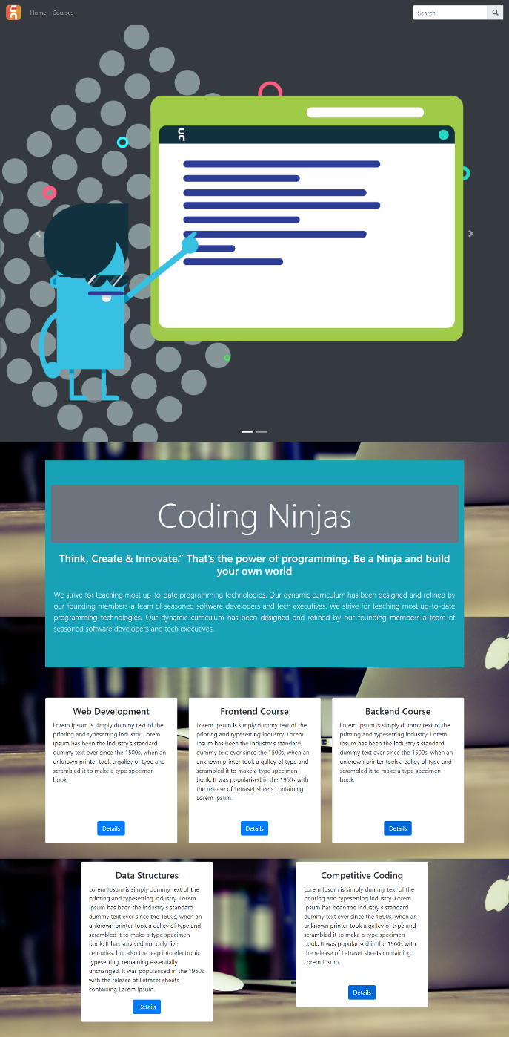

On a medium screen and above, it looks like -
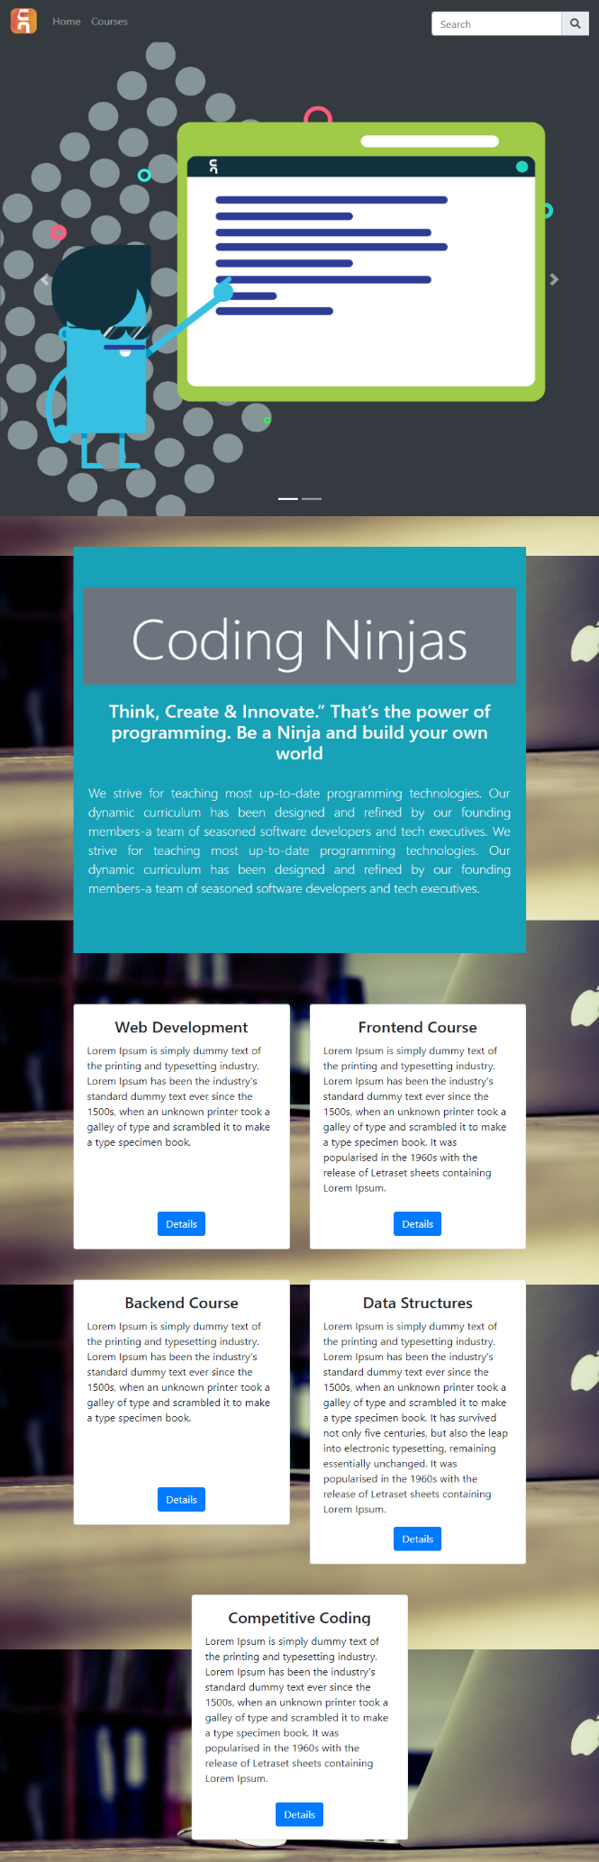

On a small screen and above, it looks like -
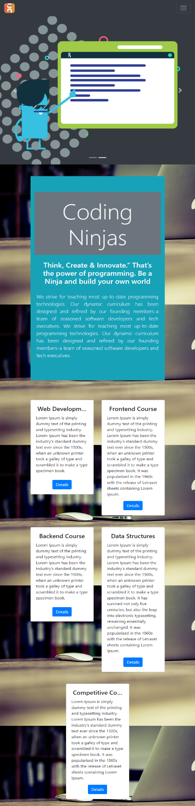

On a small screen and below, it looks like -
